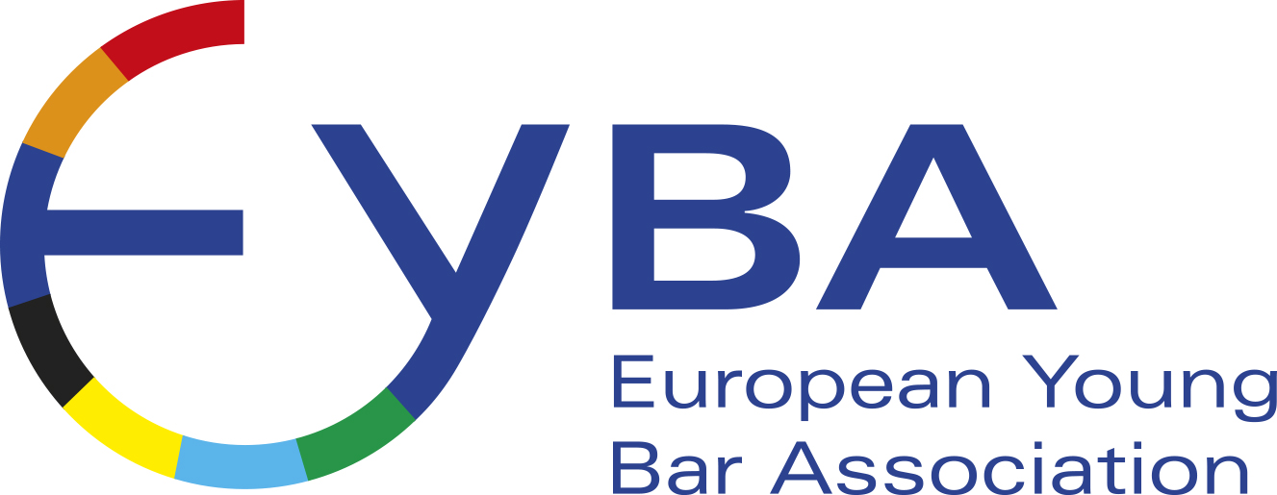

Dear EYBA member,

The EYBA Board is pleased to announce plans to incorporate into our website a list of our members, which we hope will improve networking and referral opportunities.

This list will only be available to other EYBA members who will be able to log on specifically to view and search the information.

For security purposes your information will only be included in the list if you respond positively to this request for information.

If you would like to appear on the list of EYBA members, please provide us with the following details:
Your EYBA membership status – i.e. is this through a national organisation-in such case, put the name of the organisation- or as an individual member):
Full name
Country and city you practice
Any other jurisdictions in which you are qualified
Languages spoken:
What area(s) of law you specialise in: | International Business Law / Corporate.
What area(s) of law you specialise in: | Civil Law
What area(s) of law you specialise in: | Criminal Law
What area(s) of law you specialise in: | Compliance
What area(s) of law you specialise in: | Tax Law
What area(s) of law you specialise in: | Employment Law.
What area(s) of law you specialise in: | Others areas (please, specify them)
Name and location of your law firm

Once the information has been collated and placed on our website we shall send an email to all members confirming how the data can be accessed.

If you would like any further clarification about this project please email info@eyba.org

Kind regards
The EYBA Board

